Universal Design: Designing for People with Disabilities
Compiled by Alisha Sarang-Sieminski and Adva Waranyuwat, Olin College of Engineering
ASEE 2019 Diversity, Equity, and Inclusion 100
Monday 11:30-1:00

Big Idea: Universal Access within the Classroom
- Universal design in Learning (UDL) is an approach in teaching and course design where you intentionally create an environment that tries to take into account the different ways that people with different bodies, minds, or lived experiences will engage with the environment.
- This is not about special treatment; it is about removing barriers to access by creating multiple modes of interaction and access.
- Universal design is good pedagogy, and it belongs in engineering too. Inherently, all members of the learning environment benefit when you account for a varied and diverse population.
- It takes work, and understanding your assumptions about who is in the room, it is a life-long process, and it’s doable.
- Universal design for learning (UDL) Includes Accommodation, Delivery Methods, Feedback, Assessment, Class Climate, Interactions, Physical Environments and Products, Information Resources and Technology

Universal Design for Learning Strategies (Taken from Academic Ableism by Jay Dolmage)
Use multiple means of:
- Student engagement - Why students learn (providing context and relatedness)
- Delivering content - What students learn (multimodal instruction)
- Ways for students to express themselves and act - How students learn (assessment)

Levels of accessibility to consider:
- Movement - how do we get to an event or class
- Sense - being there/how we access the material or conversation
- Architecture - orienting/how the space structures our belonging and understanding
- Communication - how we join the conversation, engage, etc.
- Agency - how we have a role shaping the event and have the right to define our own identity

Accommodations in Higher Education
- The goal is to reduce barriers to accessing education
- To receive accommodations, a student must:
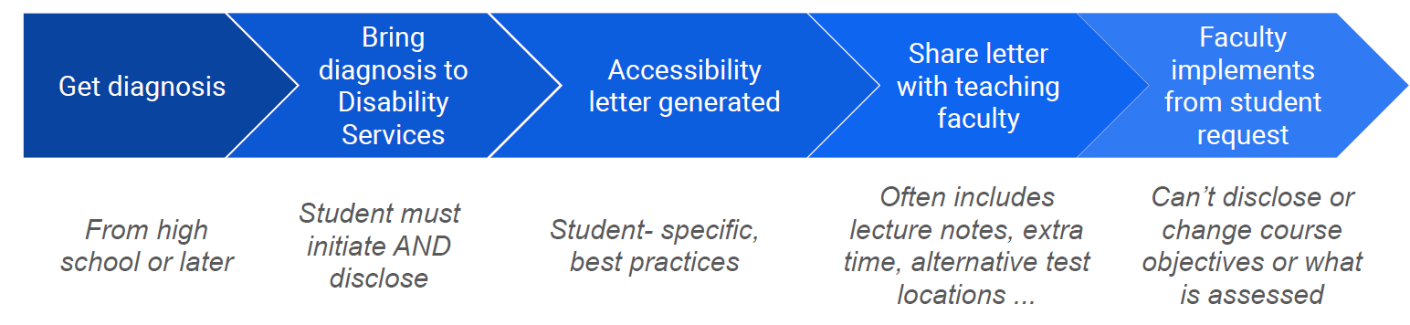
(note: “diagnosis” may not mean a specific condition, it may involve acknowledging impact on major life event)
Actionable Strategies (UDL connection in italics)
- Include an accessibility statement on your syllabus (samples below) and explicitly talk about it in class. This signals 1) multiple sources of information (written and spoken) and 2) an explicit effort on the part of the instructor to put all students on the same level.
- Be clear about the learning objectives for courses and individual assignments. This makes it easier to modify to meet the needs of the students while not changing the fundamental outcomes or what is assessed (as per the ADA). This signals 1) that the instructor can provide important context for the course, thereby increasing intrinsic motivation for everyone and 2) provides a more transparent landscape students to ask informed questions and gain agency
- Explicitly invite students to talk to you about how to adapt information in accommodations letters to meet their needs. Encourage open communication between yourself, the student, and DSO.
- Create and share electronic versions of materials. Make sure they are screen reader compatible and use alt-text on all images. This signals 1) a way to access course material in an additional way and 2) reinforcing/supporting content to aid in long-term retention of information.
- In lecture-based courses, make a statement to the entire class about having a notetaker and post notes in an accessible digital format. Some institutions have paid note-takers and many people are using use crowd-sourced notes by students. This signals 1) that all students benefit from accessing notes to reinforce understanding and 2) protects the anonymity of SWD
- Present materials in multiple modes (i.e. verbal, written, images) when possible. This signals 1) that different people process information in different ways and 2) offers multiple opportunities for any student to see the same problem in a different way
- For team projects, scaffold teaming agreements that allow students to advocate for different types of communication or working locations/times that work for them without forcing them to disclose to their team.
- Connect with your institution’s disabilities services office to know about on-campus resources and discuss cases.
- See resources below, particularly “Bridging the Gap Between Accommodations Letters and Emerging Classroom Practices,” for additional suggestions.

Resources
- AHEAD -- Association for Higher Education Accessibility and Disability (https://www.ahead.ie/udl)
- DO-IT -- Disabilities, Opportunities, Internetworking, and Technology (https://www.washington.edu/doit/)
- ACCESSComputing (https://www.washington.edu/accesscomputing/resources/teach-access)
- Work in Progress: Bridging the Gap Between Accommodations Letters and Emerging Classroom Practices, A. Sarang-Sieminski, A. Waranyuwat, E. Ferrier, A. Wood, D. Faas, 2019 CoNECD Conference (https://www.asee.org/public/conferences/148/papers/24891/view)
- Academic Ableism: Disability and Higher Education, by Jay Dolmage, University of Michigan Press, 2017 (https://www.press.umich.edu/9708836/academic_ableism)
- UDL-Universe: A Comprehensive Faculty Development Guide (https://enact.sonoma.edu/udl)
- Welcome to Universal Design: Places to Start (http://universaldesignideas.pbworks.com/w/page/97590854/FrontPage)
- Universal Design for Learning: A Rubric for Evaluating your Course Syllabus (https://drive.google.com/open?id=1NadTEUAKjIJBtIKSepzxcrKqNSks54Lk)
- Universal Design in Education: Principles and Applications (https://www.washington.edu/doit/sites/default/files/atoms/files/Universal-Design-Education-Principles-Applications.pdf)
- Sample Accessibility / UDL Syllabus Statements (from Olin College, https://docs.google.com/document/d/107Tk4-4GKcOV4MoMySZ_KV0yFkgjyGt-o3TsSG_kRgk/edit?usp=sharing)

